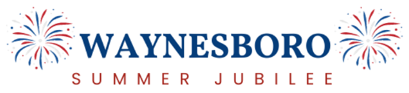

Event Description: 2025 Jubilee and Race
Sponsorship Options

Premier Firecracker 5k (Min. $3000) (Limited to 1)
- Acknowledged in exclusive spot-on social media and website.
- Exclusive Facebook post with photo and featured on the event poster.
- Promoted in all publicity
- Jubilee Provided Signs (place all along paths of event)
- Signage at Race Walk Up and Registration area (Tablecloths allowable)
- Name on race shirt

“Lady Liberty” Sponsor (Min. $3000) (Limited to 5 Sponsors)
- Acknowledged in exclusive spot on social media and website.
- Exclusive Facebook post with photo, and featured on the event poster.
- Promoted in all publicity
- Jubilee Provided Signs (Food Vendor Area)
- Name on race shirt

“Uncle Sam” Sponsor (Min. $1500)
- Acknowledged in a special thank you event poster, Facebook and website.
- Promoted in all publicity
- Name on race shirt
- You can display your own exclusive yard signage at the Jubilee (limit to 1) (craft vendor area) (Signage 18” x 24”)

“Eagle” Sponsor(Min. $1000)
- Acknowledged in a special thank you event poster, Facebook and website.
- Promoted in all publicity
- Name on race shirt

“Red and White Stripes” Sponsor (Min $500)
- Acknowledged in a special thank you event poster, Facebook and website.
- Name on race shirt

“Blue” Sponsor (Min. $250)
- Name on Race Shirt
- Displayed on Sponsor Board at Jubilee set up at Event Entrance (Helipad Area)

Shining Stars ( $249 and less)
- Displayed on Sponsor Board at Jubilee set up at Event Entrance (Helipad Area)

** The Summer Jubilee is a not for profit 501C3 organization**
118 Walnut St., Suite 111, Waynesboro, Pennsylvania 17268

